SAMUEL WEKESA BSCAS/2019/87197

BRIAN MUENDO BSCAS/2019/87801

SHARON MUMBI BSCAS/2019/88096

RISPER WANJIKU BSCAS/2019/86900

IAN NJOROGE BSCAS/2019/87944

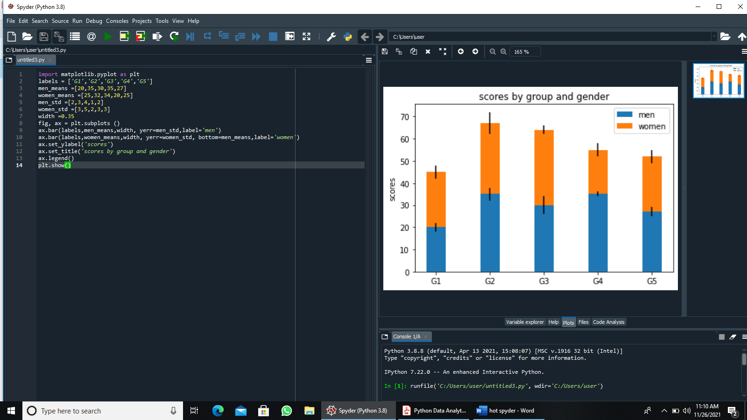 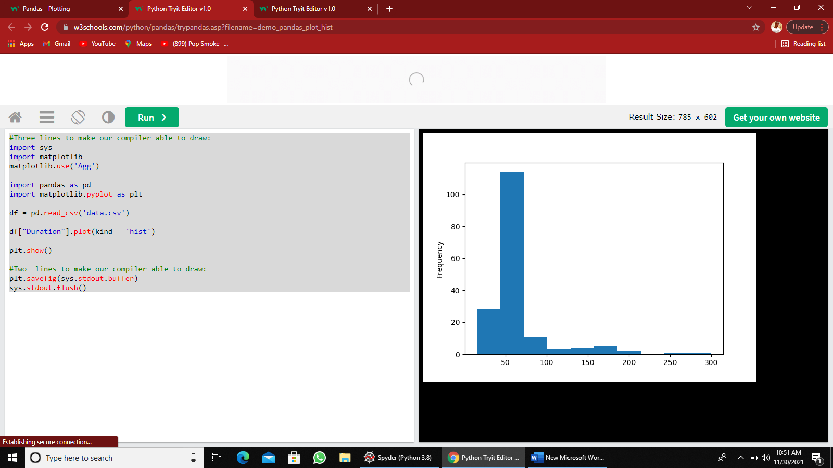Creating an array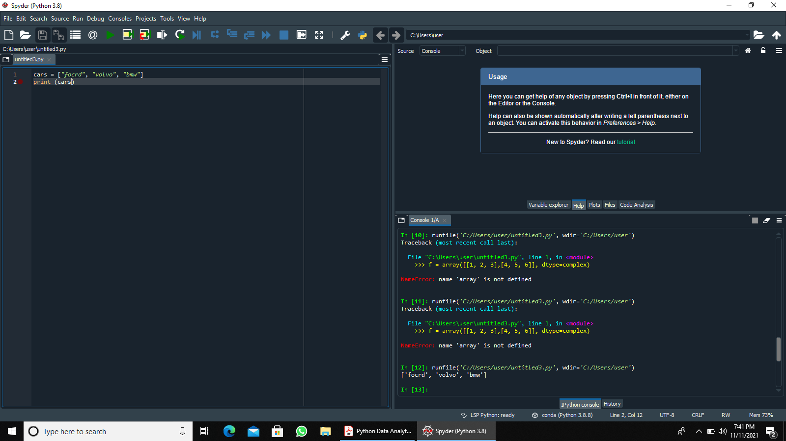

Determining the length of an array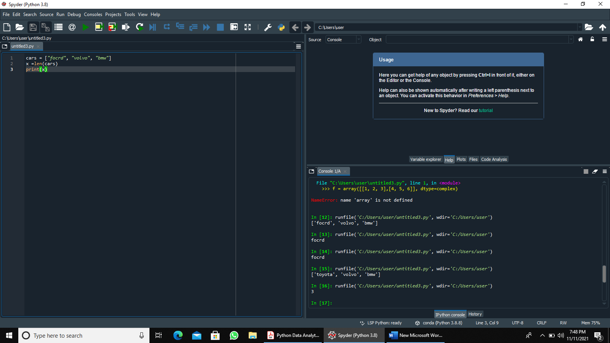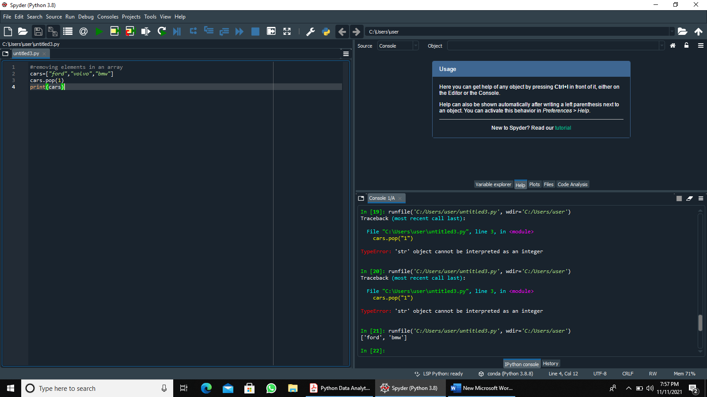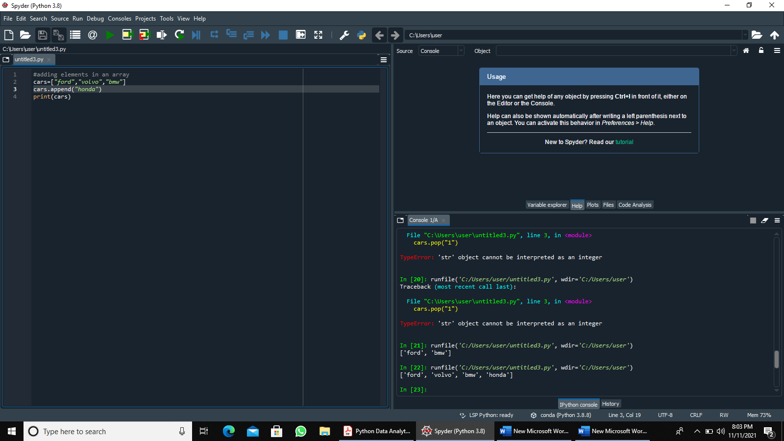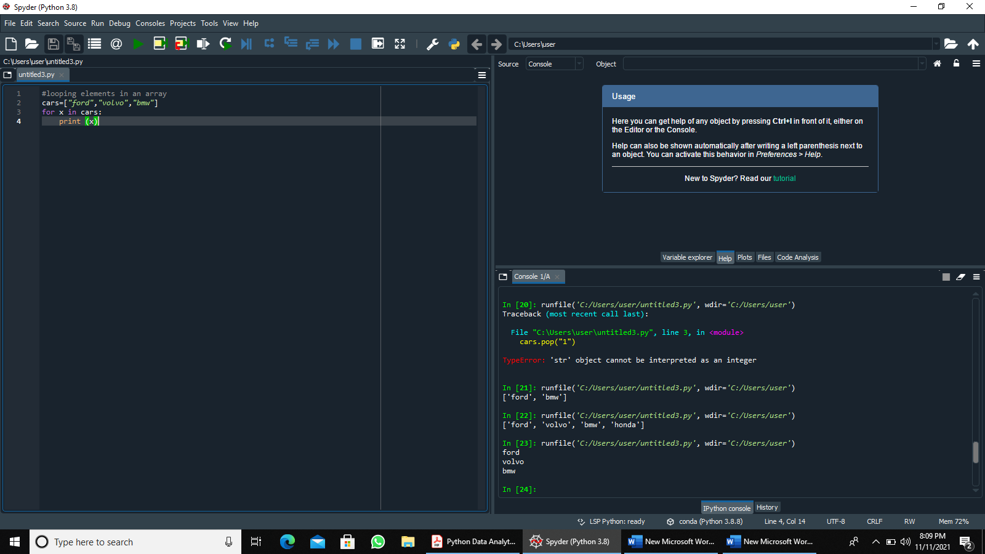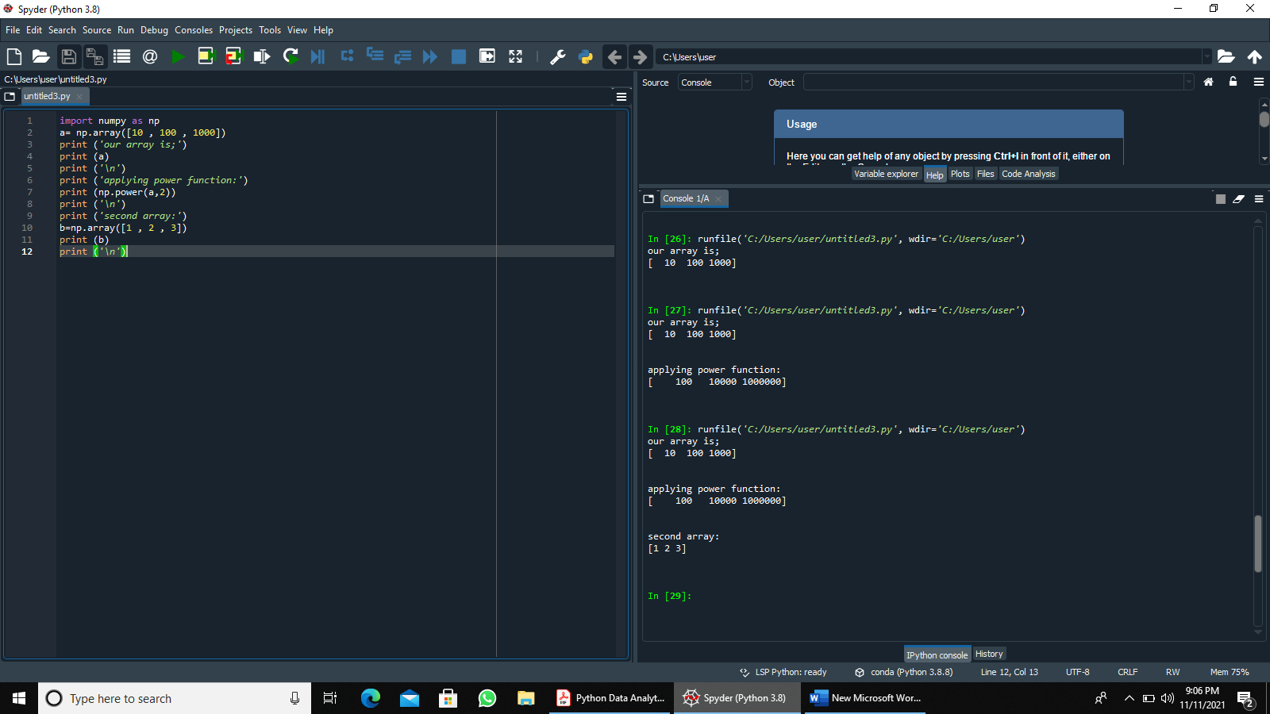

Figure 1this funtion trats elements in tne first input array as base and returns it based to the power of the corresponding element in the second input array. 